**LANDING PAGE**

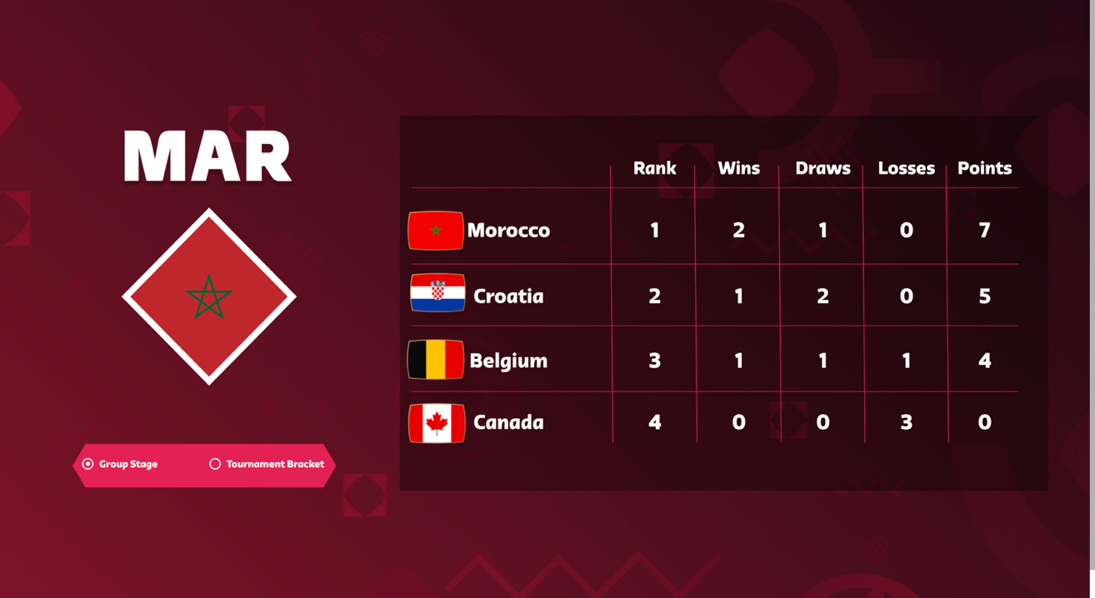

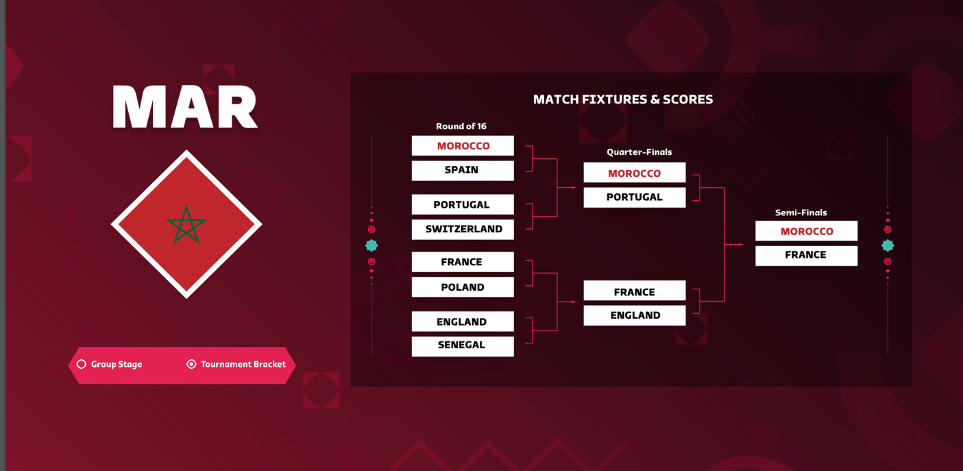

For those who’ve watched the 2022 Qatar World Cup, many would know it was full of historical upsets with fans expecting teams such as Brazil, Spain, Netherlands and Germany to take the cup home. However, Morocco went even farther into the tournament than all the teams that were mentioned.

They made it to the top of a very competitive Group Stage consisting of Croatia and Belgium. They then went on to beat giants such as Spain and Portugal which made them progress to the semi-finals; being the first ever African Country to do so and facing previous world cup champions: France. Undoubtedly, they had a spectacular run. However, the main question remains: How did they go so far? The aim of this story is to take is to answer this question with the use of data.

**MATCH DATA**

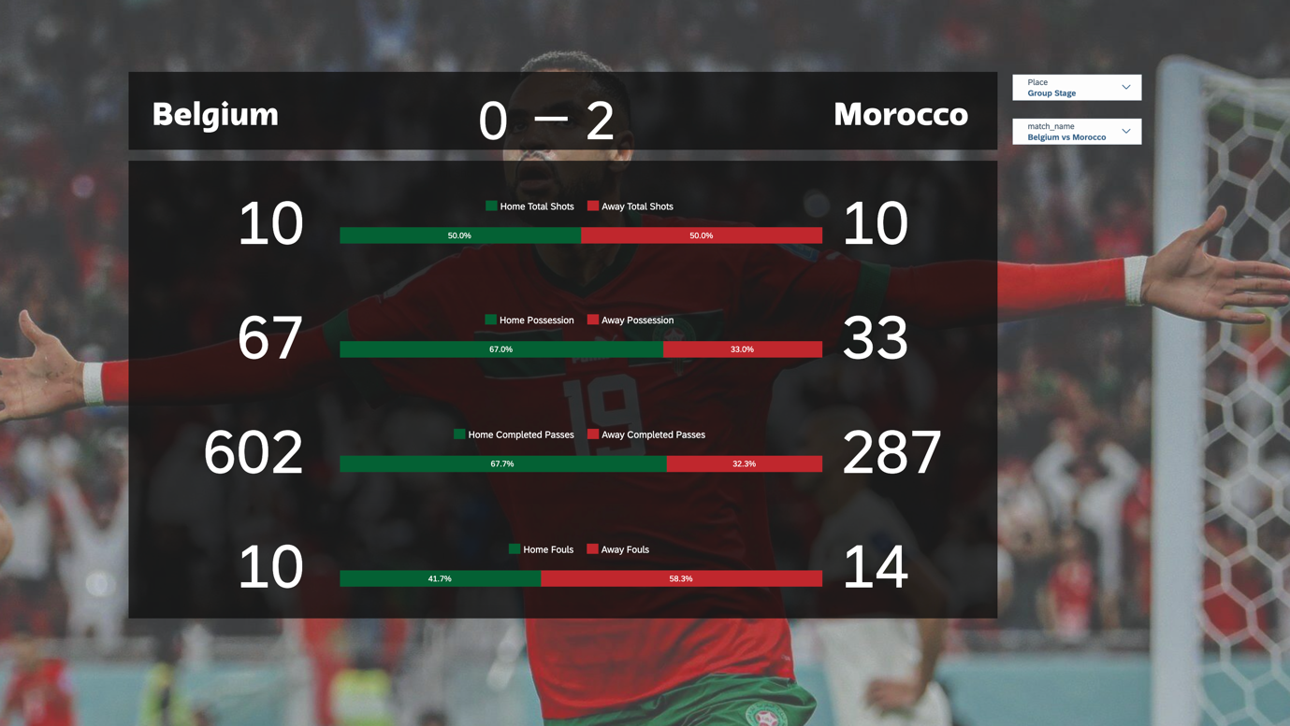

This page is an overview of their performances in each match, all the way from the Group Stages to 3rd Place. At a glance, it is obvious Morocco lacked possession, shot opportunities and passes compared to opposing teams – so was it just pure luck that they won their matches? Merely looking at the data at a surface level will allow us to answer the main question, hence a deeper dive into the data is essential.

**TEAM DATA**

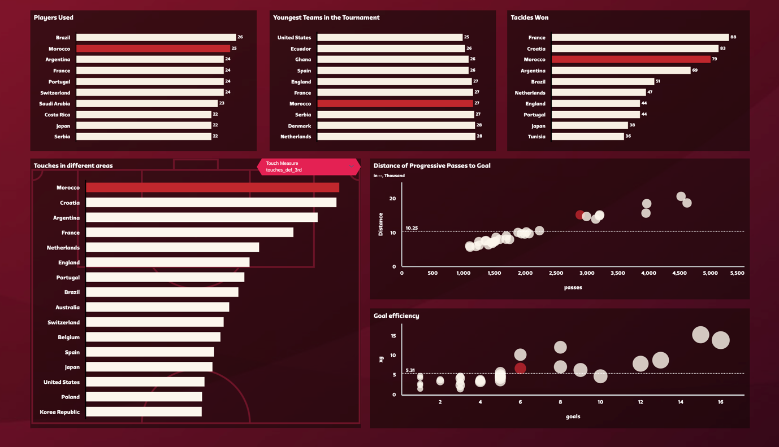

On the **Total Players Used** chart, Morocco was one of the most sustainable teams in the World Cup, using a total of 25 players, equating to 14 players substituted. This allowed Morocco’s players to retain their stamina and reduce match intensity which helped when they went on extra time.

As displayed in the **Youngest Teams** chart of that they were one of the youngest teams in the tournament, with their players averaging at 27 years old, allowing them to endure physical challenges such as creating more interceptions and tackles. On the **Tackles Chart**, Morocco was the 3rd most successful team when it came to winning tackles; stopping team’s momentum which was useful as they went against aggressively offensive-based teams in the World Cup.

The chart **Touches in different areas**, emphasises the total number of touches teams made in different zones of the field. The opponents penalty zone(Attacking 3rd) and the team’s own penalty zone(defensive 3rd). Morocco easily comes at the top when it comes to touching in the defensive third but not the attacking third, making them a highly defensive team.

However, this does not make them weak at offense because according to the **Distance of Progressive Passes Chart** (A progressive pass is any completed pass that has been made to into the opponent’s penalty area) and Morocco has created the 5th longest distance of this pass. To put this into the match perspective, the team would be in their own defensive but rapidly pass it all the way to the opposing team’s area for strikers to score.

In terms of **Goal efficiency**, they were slightly above average, scoring 6 goals to meet their expected goal ratio(a metric designed to measure the probability of a shot resulting in a goal distance to goal, angle to goal, body part with which the shot was taken, and type of assist or previous action). Because they were just slightly above average, they could not progress further in the tournament.

**GOALKEEPER DATA**

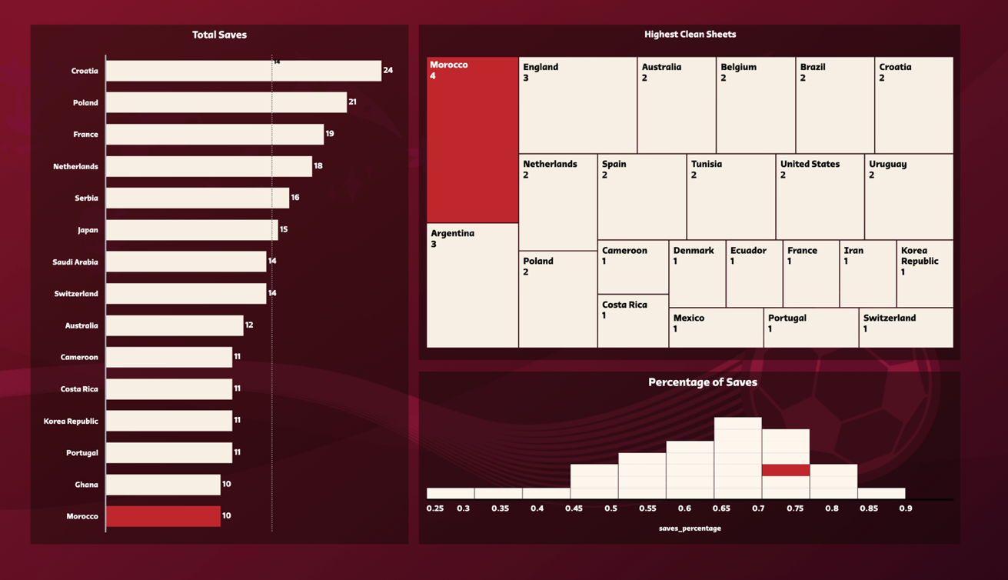

Luckily enough, Morocco has a goalkeeper to thank to prevent other teams from scoring goals. They had the highest clean sheets in the tournament (games without conceding a single goal), performing better than Argentina, England, France etc.

The **Total saves** chart clearly displays there were more goalkeepers who saved more shots than Morocco’s Goalkeeper. Therefore, we must look at the **Percentage of saves** made. So, for every shot on target that opposing teams made, what was the percentage that the goalkeeper would save them? Based on this, Morocco saved it 77% of the time.

**CONCLUSION**

In conclusion, the team consisted of a great goalkeeper that prevented teams from scoring, a solid defence that could counter aggressive teams helped Morocco but the lack of goal scoring ability from their strikers prevented them from going even further in the tournament. Nevertheless, this will remain a huge historical achievement for the Arab and African World.